Chapter 7, Problem 16.

Determine the time constant for each of the circuits in Fig. 7.96.

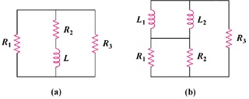

Figure 7.96
For Prob. 7.16.

